**UNITY WEBTOOL HOW-TO:**

1. Download or clone the project from <https://github.com/mattgil23/Unity2Web>. Make sure to get the commit version “Complete Project”. Unzip it.

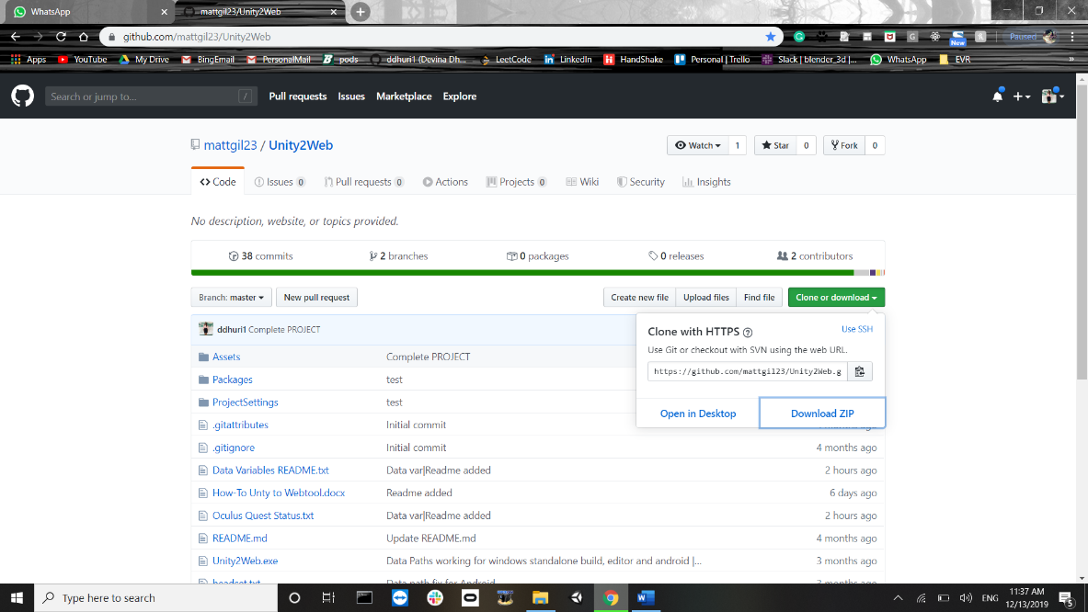

1. Download Unity3d 2019.1.4f1 <https://unity3d.com/get-unity/download> and UnityHub.
2. Open Unity Hub and add the new downloaded project to it.

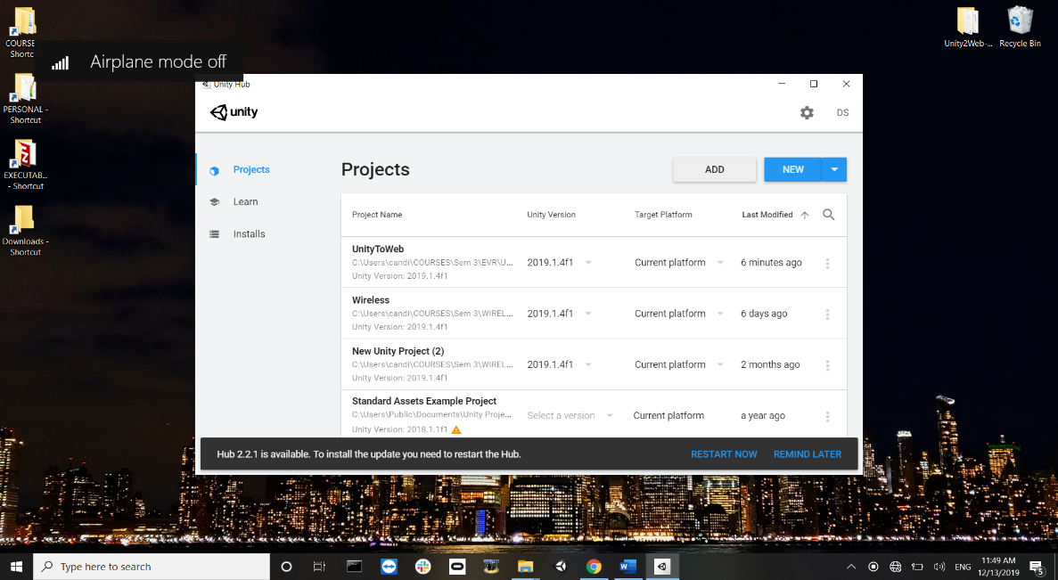

1. Once added, open the project.

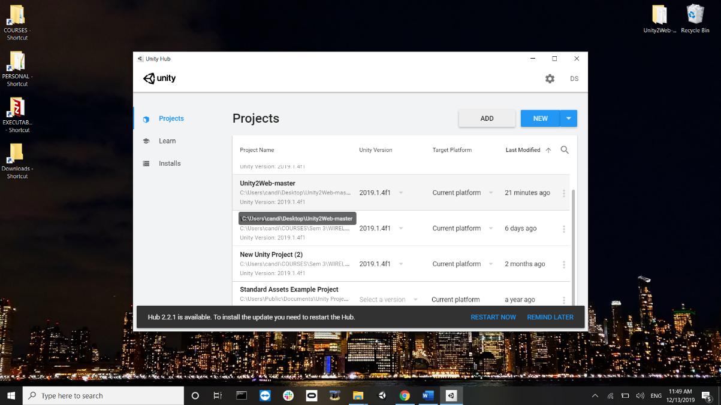

1. Once opened, Under the project panel, Assets -> EVR -> Test, open the test scene.

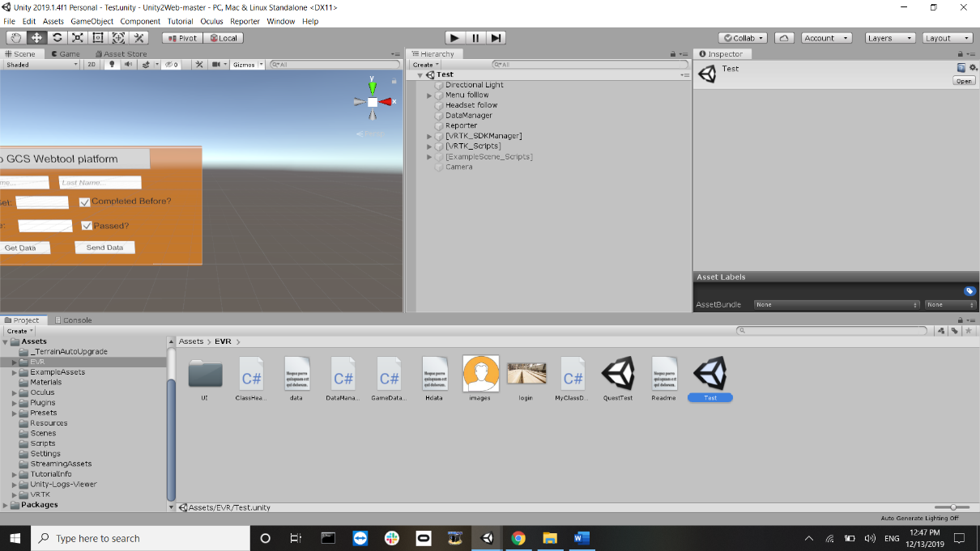

1. Under “Hierarchy”, click on “DataManager”. Under the “Inspector” for it, you will find the “User Information” tab empty.

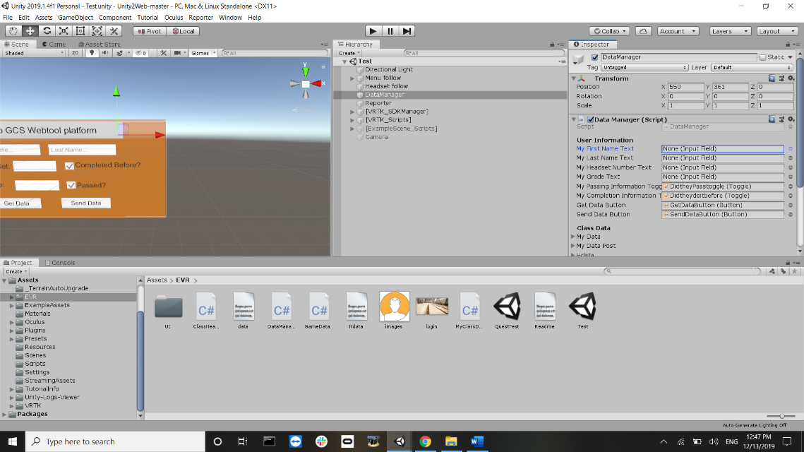

Under the Hierarchy tab, click on “Menu Follow” and drag and drop the respective items under the inspector for DataManager.

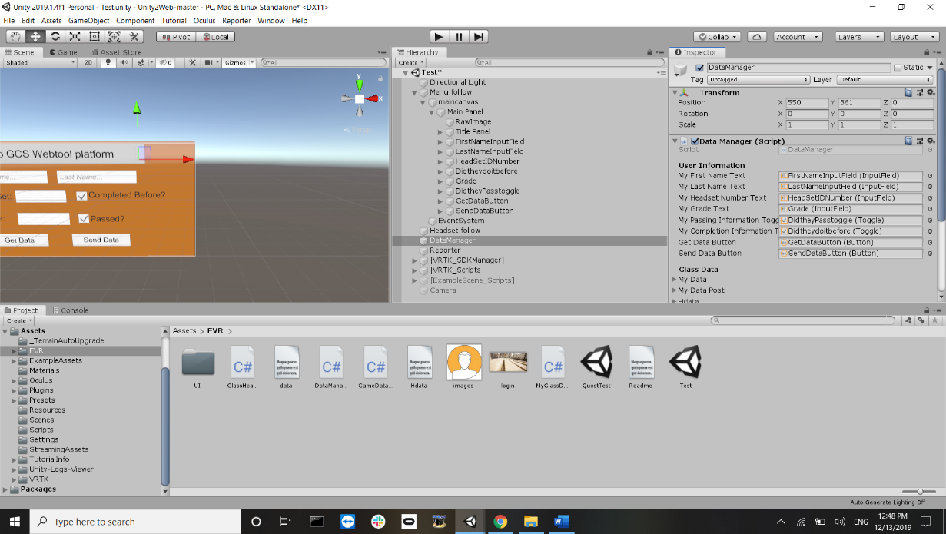

1. Under the inspector for DataManager, fill n the path for the windows/Android platform where the text files reside. (Text files should be downloaded with the project).

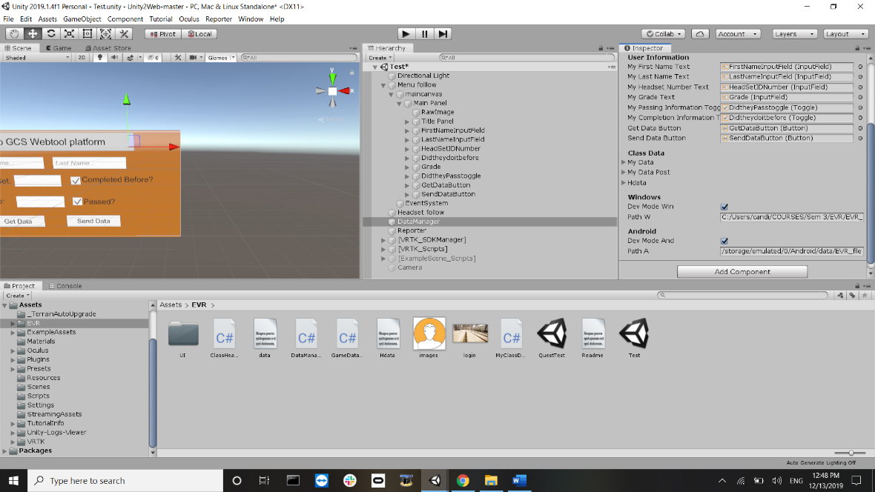

1. If testing on Windows, without Headset, comment the VRTK objects under Hierarchy. If using VRTK, under “VRTK SDK Manager”, untick the auto loads. This helps to maintain Virtual Reality settings when using the headset.

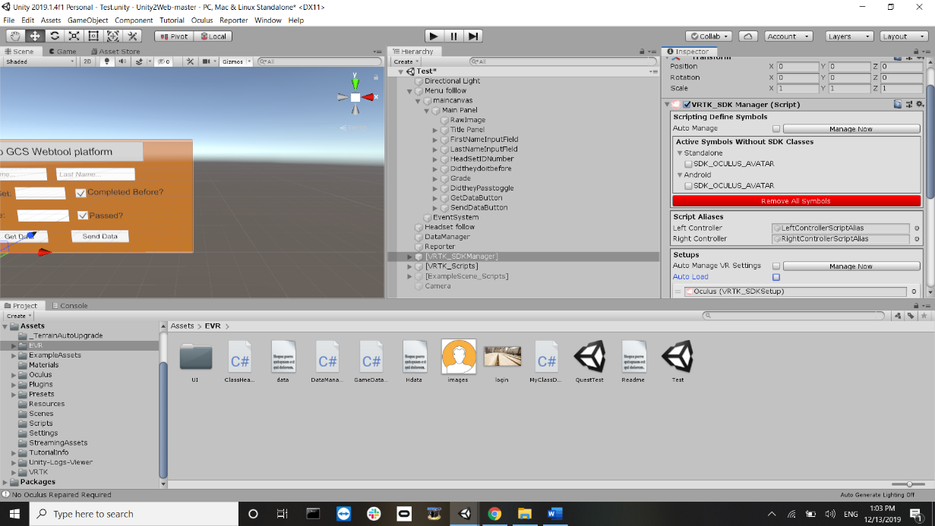

1. Under Build Settings -> Player Settings, click on android and under XR settings, select VR support and add Oculus at the VR SKD.

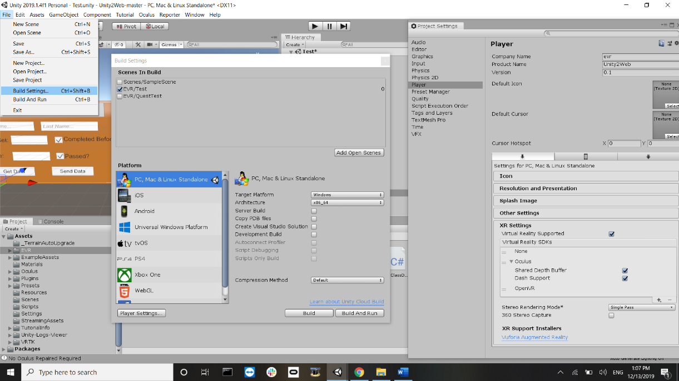

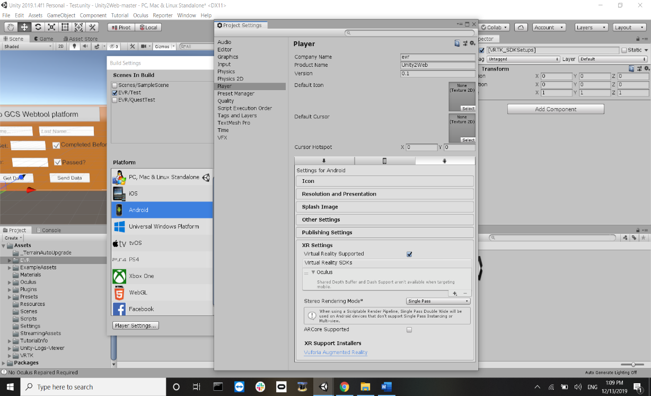

Enter the company name and product name on the top of the player setting panel, and Under Other Settings-> Identification -> Package name, add *com.CompanyName.ProductName*

1. Under the build settings, add the test scene to the Build scenes, switch the platform s needed. If Android, under “Run Device”, select the added/ plugged Oculus device. Click on “Switch Platform” once done.

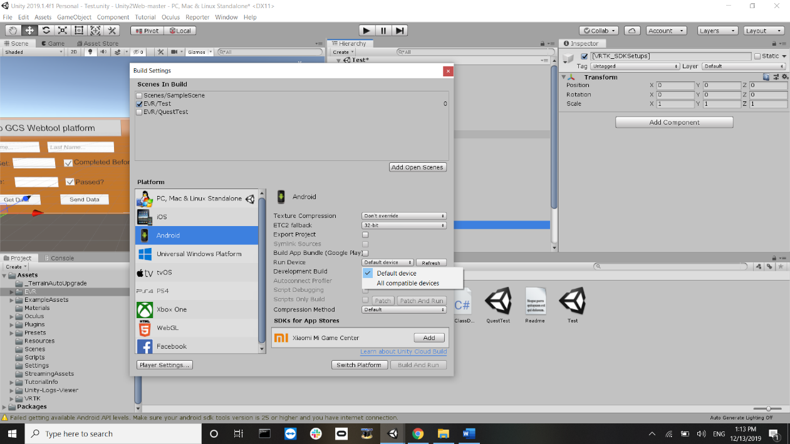

1. Then Build and run. If testing on **Windows**, directly hit play and **avoid step 9**.
2. Before you get data, hit the “Get Button”, make sure to

* Go to <https://evr-demo.herokuapp.com/experience/new>
* Add a new user or choose an existing user and create setup.

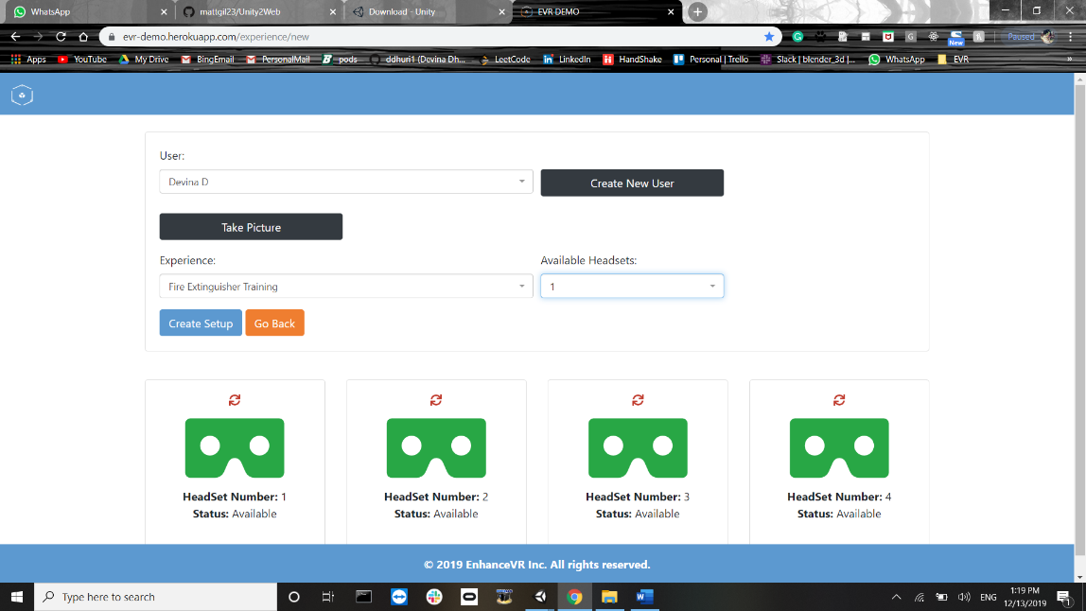

* Choose the headset number based on the number in Headset.txt.
* Then click on getData in the app.
* The Headset.txt is a json format containing headset id, get URL and Send URL. Change as needed.

*EG: {"HeadsetID":"1","GetEndPoint":"http://evr-demo.herokuapp.com/test?","PostEndPoint":"http://evr-demo.herokuapp.com/test"}*

* Read the “Oculus Quest Status” for the build progress and to-do on Oculus.
* Data Variables used in the project are explained in “Data Variables README.txt”